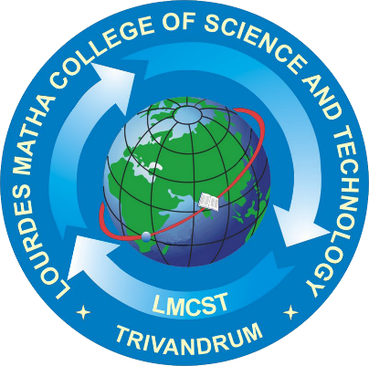

STYLEGEN: IMAGE STYLE TRANSFER USING VGG-19

**(20MCA246)**

**MAIN PROJECT REPORT**

**LOURDES MATHA COLLEGE OF SCIENCE AND TECHNOLOGY KUTTICHAL, THIRUVANANTHAPURAM-695574**

**(MANAGED BY THE ARCHDIOCESE OF CHANGANASSERY)**

DEPARTMENT OF COMPUTER APPLICATIONS

(Affiliated to APJ Abdul Kalam Technological University,Kerala (KTU))

Submitted by:

**DEEPAK V**

**LMC21MCA-2017**

